**Supplementary Requirement Release 2**

1.FV - Field Validation Requirements

   1.1.Field “Card Holder Name”

**Scope:**

* UC05.01 Add Payment Information
* UC05.02 Update Payment Information

**Requirements:**

* Field is mandatory, system should not allow to proceed without Card Holder name and system should show the message “Card Holder Name cannot be Empty”
* Field size should be no longer than 200 characters.
* Field should not contain special characters and system should show message “Special Characters are not allowed for Card Holder Name”
* Field should not contain numbers and the system should show the message “Numbers are not allowed for Card Holder Name”.

1.2.Field “Card Number”

**Scope:**

* UC05.01 Add Payment Information
* UC05.02 Update Payment Information

**Requirements:**

* Field is mandatory, system should not allow to proceed without Card Number and system should show the message “Card Number should not be empty”
* Field size should be no longer than 16 digits and the system should show the message “Card Number should be only 16 digits”.
* Field should only contain numbers and the system should show the message “Please enter only Numbers”.

1.3.Field “CVV”

**Scope:**

* UC05.01 Add Payment Information
* UC05.02 Update Payment Information

**Requirements:**

* Field is mandatory, system should not allow to proceed without Card Number and system should show the message “CVV number should not be empty”
* Field size should be no longer than 3 digits and the system should show the message “Card Number should be only 3 digits”.
* Field should only contain numbers and the system should show the message “Please enter only Numbers”.

**Conditions to Apply:** After the respective join points.

| 2. 2.DF-In - Data Flow In Requirements |
| --- |

**Scope:**

* UC02.2 Search by Keyword
* UC05.2 Update Payment Information
* UC05.3 Delete Payment Information

**Requirements:**

* [UC02.2] Search by Keyword should only return data if the keyword entered is provided in service type and service location during registering a Service Provider Account.
* [UC05.2-UC05.3] The data for Updating Payment Information and deleting Payment Information will be available from [UC05.1] when submitting the Payment Information initially.

**Conditions to Apply:** After the respective join points.

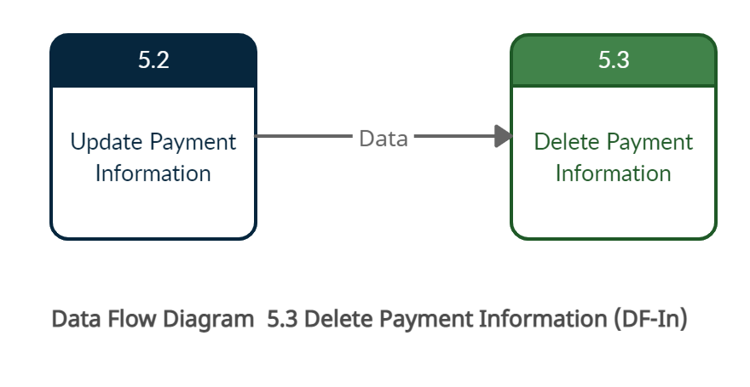

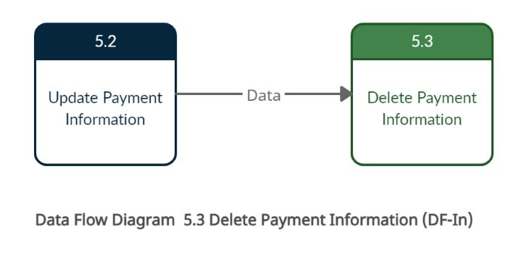

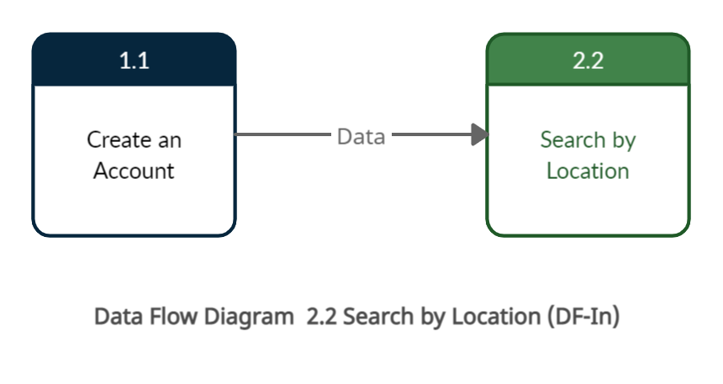

| 3. DF-Out - Data Flow Out Requirements |
| --- |

**Scope:**

* UC05.1 Add payment information
* UC05.2 Update payment information

**Requirements:**

* Based on the values entered in the Add payment form the card holder/ card information should appear on the Update Payment information page.
* Based on the values entered in the Update payment form the card holder/ card information should appear on the Delete Payment information page.

**Conditions to Apply:** After the respective join points.

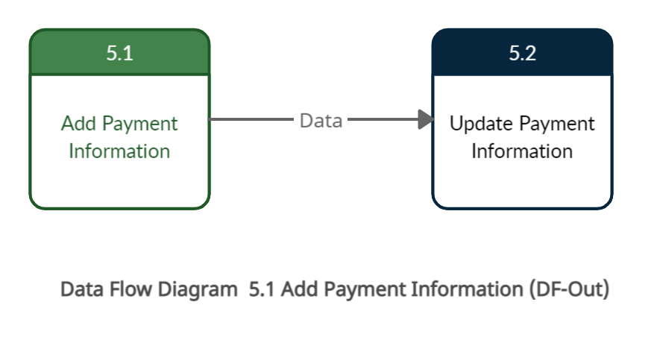

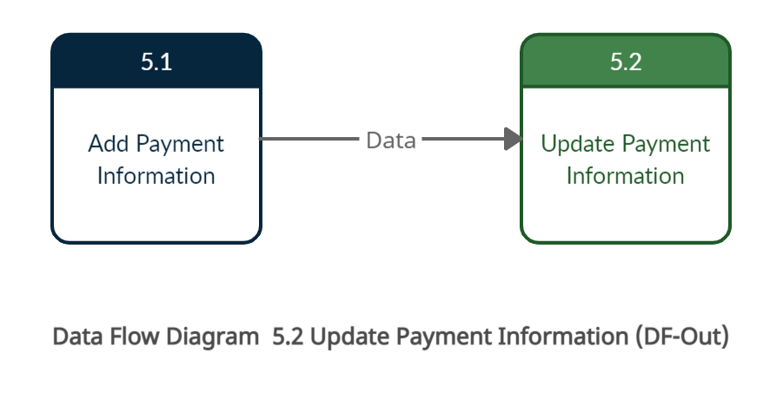

4. Data-Dependency Validation Requirements

4.1. Fields “Service Type” and “Location”

**Scope:**

* UC02.2 Search by Keyword

**Requirements:**

* If system does not contain the Keyword combinations of the service and/or the location, the user gets the message “Providers not found”.

**Conditions to Apply:** After the respective join points.